Listen, observe, act – in step with God

Some Listening and Observing Activities

In this section, there are a few short activities relating to listening and observing which you could use throughout the year at your meetings.

Or why not use them together as a way of thinking about listening and observing, together with some of the worship suggestions included in this year’s theme materials.

Chinese Whispers

This is a familiar game from childhood, but is a really good example of how our listening sometimes lets us down!

Sitting in a circle or semi-circle, whisper a short message to the first person. This person passes the message on to the person sitting next to them.

Don’t make the message a tongue twister or over- complicated. Try something like:
“Mothers’ Union is a international Christian charity with over four million members in 84 countries”

The last person to receive the message should say it out loud to the rest of the group.

It’s quite unusual for a message to be passed round absolutely correctly, even when everyone is trying to listen.

Some background information

The game is called by different names in different countries and there is no particular reason why it is known as Chinese Whispers in many English speaking countries. It may be because the Chinese language is considered to be difficult to understand.

As this is a listening game, it is interesting to look at the Chinese symbol for ‘Listening’. This is a combination of the symbols for:
- Ears
- Eyes
- Heart
- Mind
- Undivided Attention

And if we are to listen well- to each other and to God – we need to give our undivided attention and use not just our ears, but also our eyes, heart and mind.

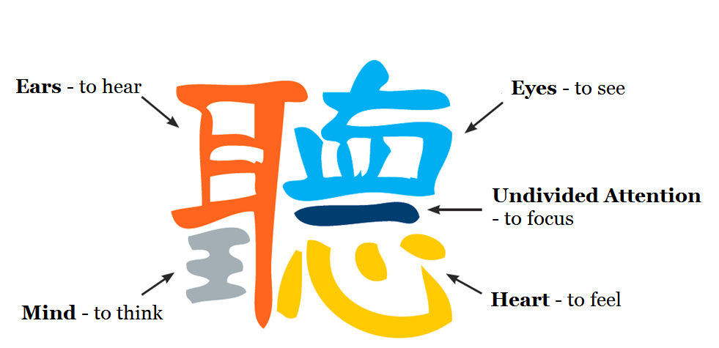
What do you see?

On the following pages are some ‘Illusion’ pictures - effectively two images in each picture. Some people will see one thing – and other people will see something rather different. With a bit of guidance, everyone will probably be able to see both images.

Pass these pictures around your group – and see which image most of them can see. There are notes after the pictures to help people find the alternative image.

This is a bit of fun, but it does show how different people can see things differently – even if looking at the same thing. And that once you have one image in your mind, it’s quite difficult to see the other.

These are only pictures, but there are many instances in real life where some people will see and interpret the same situation differently.

What does this say to us as Mothers’ Union members when as we try to discern what we are called to do to make a difference to family life in our community?

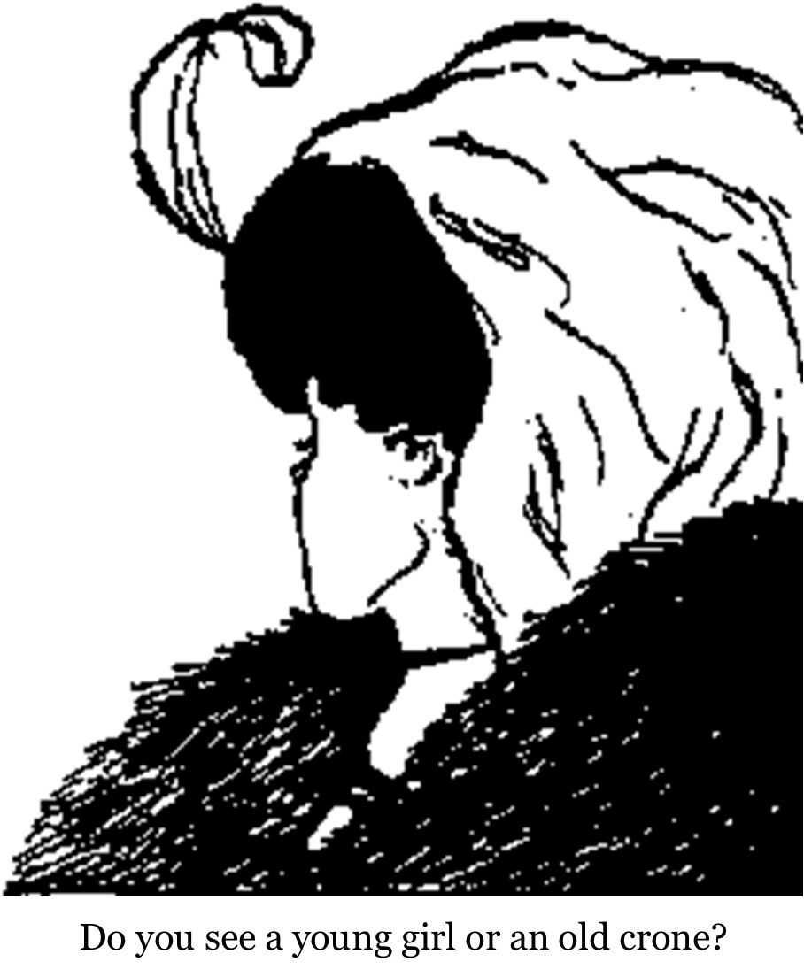

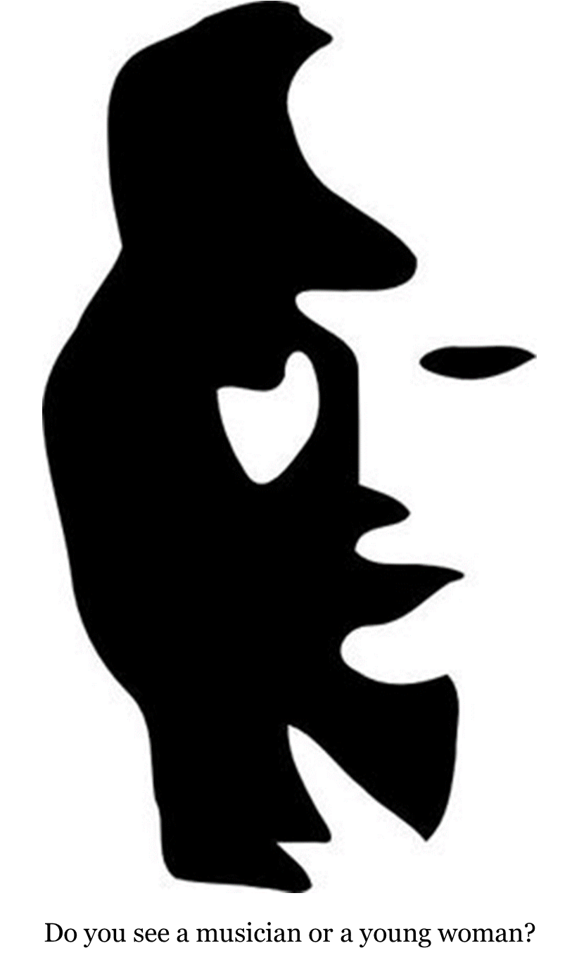
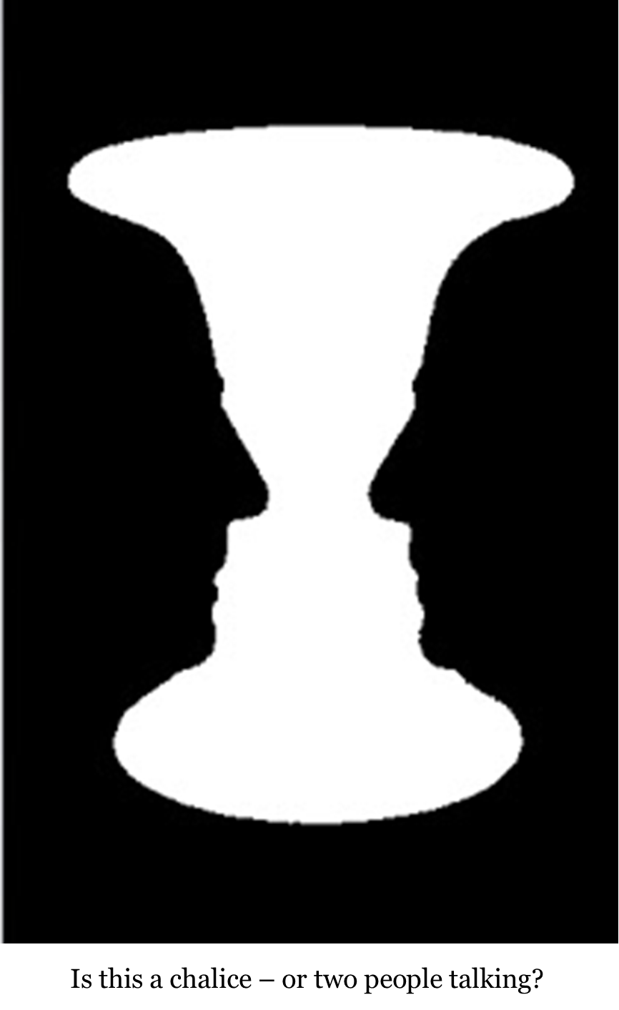

Illusion picture explanations

Do you see a young girl – or an old crone?
If you think this is a young girl, see how the necklace could be the mouth of an old crone, the chin profile becomes a large nose and the ear becomes an eye – and vice versa.

Do you see a musician or a young woman?
Can you see how the dark side of the young woman’s profile becomes a man with a very prominent nose playing the saxophone?
And if you only see the musician, the hands round the saxophone become her nose and a mouth and the curve of the saxophone becomes her chin.

Is this a chalice – or two people talking?
How you see this picture will depend on whether you focus on the black silhouette which shows two people with identical profiles – or focus on the white outline chalice in the centre….

Can you explain how this happened?

Read out the following paragraph and ask for some logical explanations…

A man dressed completely in black– he wears a black shirt, pants, shoes, and even a black mask - walks down the street with all the street lamps off.

A black car is coming towards him with its lights off, but the driver somehow manages to stop the car before hitting the man.

How could the driver see the man?

What is the solution?

The solution was in the details that were omitted from the story and is actually very straightforward:

This happened during the day, so it doesn't matter if everything else the man was dressed completely in black - or that the street lights were off. After all, the street lights are usually off during the day.

If we don’t have the whole picture, we tend to add in what seems to be the missing detail – without realising it. In this example, saying that the street lights were out and the car had its lights out leads you to think that this was in some way unusual and therefore we make the assumption that it was night. It’s important to make sure that we don’t make assumptions when listening to others. If something isn’t clear, ask – don’t assume!

Other listening and observing activities

Kim’s Game

The 2018 theme activities included ‘Mary’s Game’ – a form of Kim’s Game relating to Mary Sumner and the example she set for Mothers’ Union going forward.

Another variation on Kim’s Game to check out our observation skills is to have a table or tray of random objects. Allow everyone a few minutes to look at the objects, then cover the table or tray with a cloth and carefully (without anyone seeing) either remove an item, add an item or exchange an item. Remove the cloth and see who observes the difference in items correctly.

Video Clips

There are a number of fun video clips on You Tube that test observation powers – some of which may be familiar to you. Put ‘Observation video gorilla’ in your search engine to find a selection.
Please note: Most of these are videos to promote books and other resources, but nevertheless are a useful tool to highlight our observation skills (or lack of them!).

